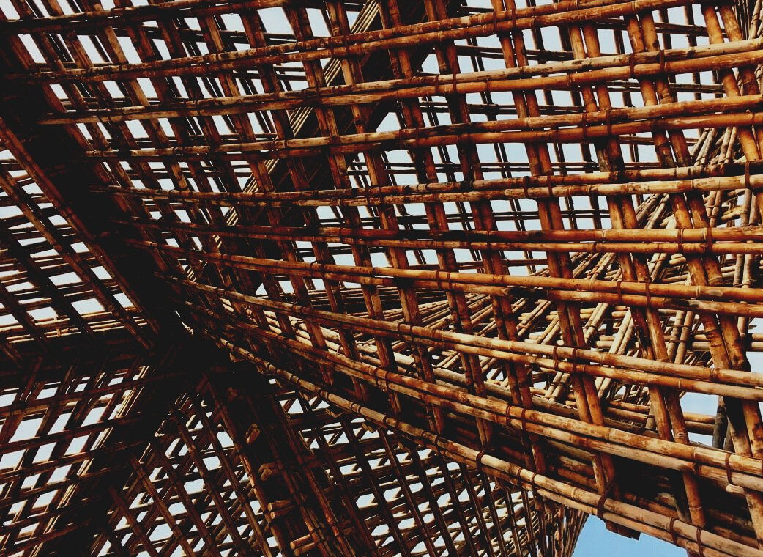

**TRAINING & ASSESSMENT**

**MATERIAL**

Learning Unit 1

Lesson 1: Wood properties, its limitations and wood construction physics.

UPWOOD

*Up-skilling construction workers in wood construction methods for energy-efficient buildings*

UPWOOD

*Up-skilling construction workers in wood construction methods for energy-efficient buildings*

*construction workers in wood construction methods for energy-efficient buildings*

*methods for energy-efficient buildings*

UPWOOD

*Up-skilling construction workers in wood construction methods for energy-efficient buildings*

*methods for energy-efficient buildings*

UPWOOD

*Up-skilling construction workers in wood construction methods for energy-efficient buildings*

*truction methods for energy-efficient buildings*

UPWOOD

*Up-skilling construction workers in wood construction methods for energy-efficient buildings*

*methods for energy-efficient buildings*

UPWOOD

*Up-skilling construction workers in wood construction methods for energy-efficient buildings*

*methods for energy-efficient buildings*

UPWOOD

*Up-skilling construction workers in wood construction methods for energy-efficient buildings*

*methods for energy-efficient buildings*

UPWOOD

*Up-skilling construction workers in wood construction methods for energy-efficient buildings*

**CONTENT**

1. INTRODUCTORY PARAGRAPH 2

2. LECTURE NOTES 3

2.1. Wood structure and appearance 3

2.2. Physical properties 5

2.2.3. Odor and taste 5

2.2.4. Moisture content and water in the wood 5

2.2.5. Density 8

2.2.6. Dimensional stability and shrinking/swelling 9

2.2.7. Wood defects– make influence to structural properties 10

2.3. Mechanical properties 13

2.3.1. Viscoelasticity 14

2.3.2. Compression strength 14

2.3.3. Bending static strength 15

2.3.4. Tensile strength 16

2.3.5. Shear strength 16

2.3.6. Impact bending, toughness and dynamic properties 16

2.4. Technological properties 16

2.4.1. Wood Drying 17

2.4.2. General overview of sawing wood materials 17

2.5. Operational properties 18

2.5.1. Thermal characteristics 18

2.5.2. Nail or screw resistance 18

2.5.3. Hardness of wood 19

2.5.4. Abrasion resistance of wood 19

2.5.5. Sound velocity 19

3. LIST OF REFERENCES 20

# INTRODUCTORY PARAGRAPH

As described many times in this learning material, amongst other properties wood is: efficient, durable and useful wood products produced from timber, a minimally processed as log for cabin houses till up to a highly processed engineered wood products (EWP), such as wood based panels etc. This learning unit (LU1) shows structure of wood, benefits of using wood for structures and also how to deal with technologies for improving some of the wooden properties.

However, to use wood to its best advantage and most effectively in different engineering applications, specific characteristics or physical-mechanical, technological and also operational properties must be considered even more compared to other building materials. In last 5 years 13 seven-stories or taller are built and 19 are underway to have been built (Fig.1.1.).

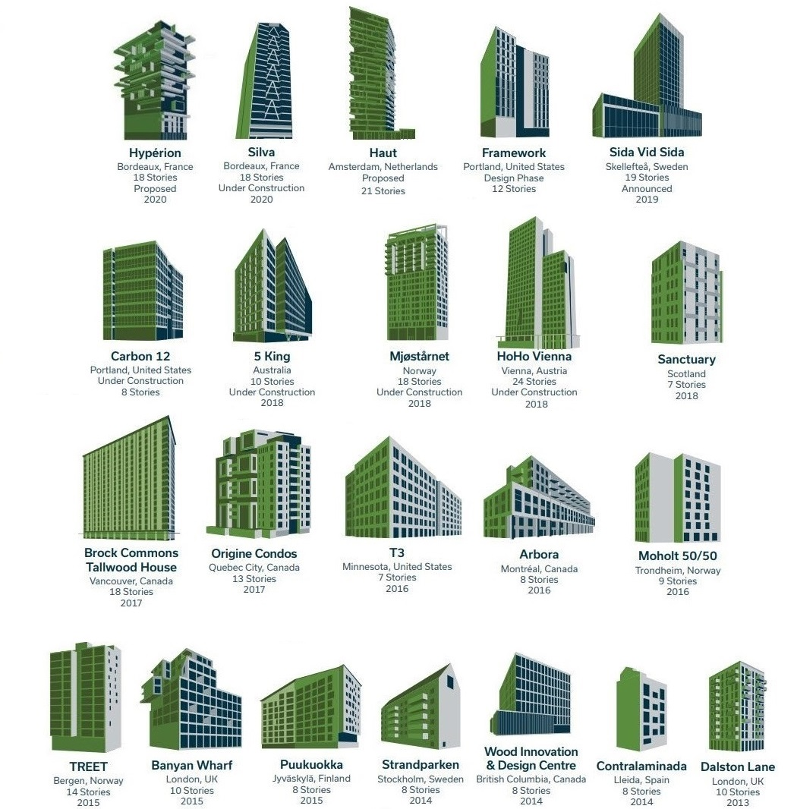

**Fig.1.1. Timber buildings in last five years[1]**

# LECTURE NOTES

## Wood structure and appearance

Wood consists of organic substances, which contain the following chemical elements: carbon (*C*), hydrogen (*H*), oxygen (*O*) and nitrogen (*N*). Tree species have no effect on chemical composition of the wood. Medium dry wood contains 49 to 50% carbon, 6% hydrogen, 43 to 44% oxygen and only slightly 0.12% nitrogen. All wood is composed of lignin, cellulose and hemicelluloses (Fig.1.2.).

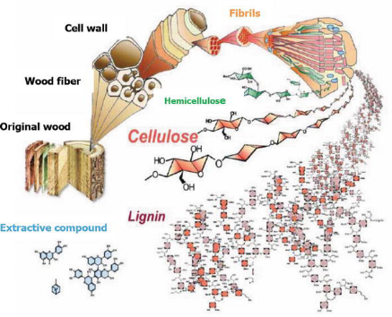

**Fig. 1.2. Composition of wood microstructure**(Theapparat and Chandumpai, 2018)

The result of cellulose is paper and reaction by-products. Lignin is used for heating, for making moulds, for the production of plastics, vanillin and activated carbon, itself it is a glue. Hemicelluloses can be used for production of furfural which can be converted into a variety of solvents, polymers, fuels and other useful chemicals by a range of catalytic reductions. Variations in the characteristics and proportions of these components and differences in cellular structure make woods heavy or light, stiff or flexible, hard or soft and etc.

Trees are divided into two broad classes: hardwoods and softwoods (Fig.1.3.). Softwoods (in Latin *Coniferous*) are not all soft, lightweight wood. They are those woods that come from gymnosperms and generally needle-leaved evergreen trees such as pine (*Pinus sylvestris* L.), larch (*Larix* Mill.) and spruce (*Picea abies* (L.) H. Karst.). Most used wood species for structural uses in Europe are all three above mentioned. Hardwoods (in Latin *Deciduous*) are not all hard, heavy wood that come from angiosperms (flowering plants). They are typically broadleaf, deciduous trees such as maple (*Acer Pseudoplatanus* L.), birch (Betula pendula Roth.), and oak (*Quercus robur* L.). Most imported abroad of European Nation (EU) woods are hardwoods (mostly tropical ones).

General names of the species can be confusing because some softwoods are actually harder than some hardwoods, and on the contrary some hardwoods are softer than some softwoods. The difference between hardwood and softwood says nothing about the density and neither other properties of the wood.

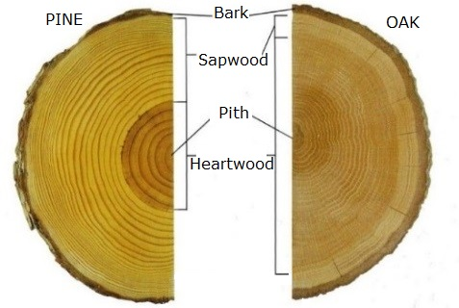 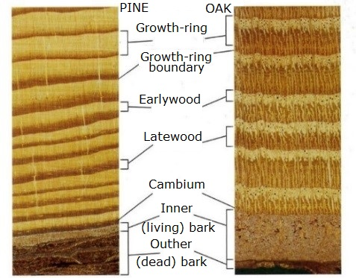

**Fig. 1.3. Trees on macro and semi-micro level** (Hoadley, 2000)

For example, softwoods such as Douglas-fir (*Pseudotsuga menziesii*) and larch (*Larix* Mill.) are typically harder than the hardwoods aspen (*Populus tremula* L.) and lime (*Tilia cordata* Mill.). Hardwoods are porous (Fig.1.3.), that is, they contain vessel elements or wood cell with open ends.

In contrast to other building materials - steel and concrete, wood is an orthotropic material, meaning its properties are different in three directions – longitudinal, tangential and radial, as illustrated in figure 1.4.

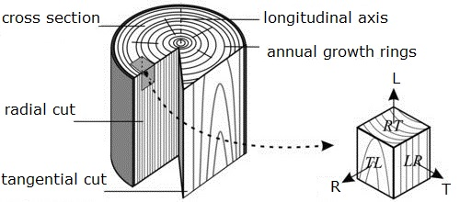

**Fig. 1.4. Wood cross cuts** (Wertheimer, 2019)

The outcome as boards of timber visually has shown in figure 1.5. It can be seen the structure of cutted boards are totally different (Fig.1.5.).

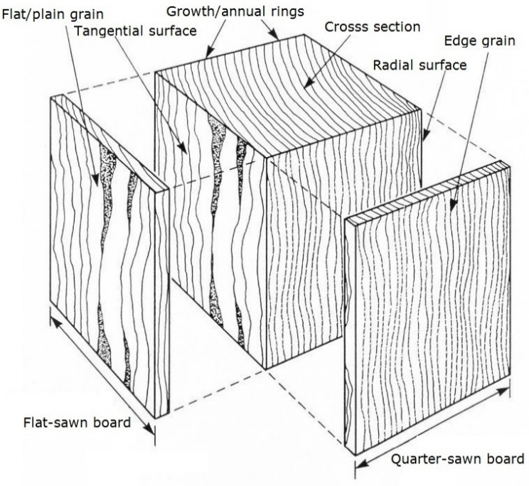

**Fig. 1.5. Cuts of the boards[2]**

Sawing of wooden materials will be in section 2.2.6.

And if the structure is different, the properties should be different as well. In figure 1.6. is shown mechanical processes of cutting the round timber.

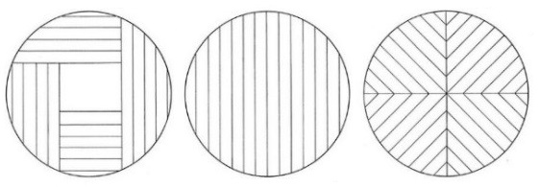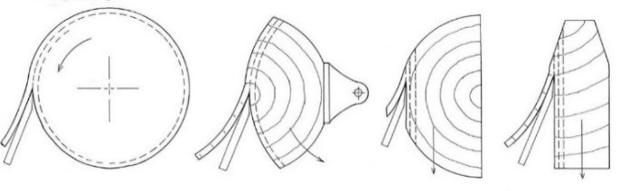

|  |  |  |  |  |  |  |
| --- | --- | --- | --- | --- | --- | --- |
| A | B | C | D | E | F | G |

**Fig. 1.6. Cutting of timber** (Hoadley, 2000): A- sawing around the log produces flat-grain boards; B- sawing through the log produces combination; C- quarter-sawn boards; D- rotary cutting; E- half-round slicing; F- flat-slicing; G- quarter-slicing.

First three cuttings of timber relate to sawn materials (relatively wide, thick and length), which are used the most for wooden structures. Lower part relates to veneer production (relatively wide, not thick, not length) and usually used for plywood and other wood-based panels productions (Lesson 2 of this LU1).

Mechanical properties - viscoelasticity, bending, compression, tensile strength etc. in all wood directions (tangential, radial and axial) vary. These and many other characteristics of wood should be taken into consideration for an efficient practical design and before using wood in constructions several properties should be known, such as:

* physical (structure and odor, moisture content, density, dimensional stability etc.);
* mechanical (viscoelasticity, bending, compression strength etc.);
* technological (drying, machining, storage etc.);
* operational (surface covering, hardness, abrasion resistance etc.).

## Physical properties

### Odor and taste

Many timber species have specific odor, which is more effective during fresh conditions. It gradually disappears with the passage of time. For example oak has objectionable odor which gradually disappears with the passage of time. The taste of wood is greatly related to the odor probably traced to the same constituents. Both properties compel to use wood in proper place. Bad smelling wood should not be used in environment related to food preparing processes. Odor or taste are not the most vital properties for using timber in structures.

### Moisture content and water in the wood

Wood, like many other natural materials, is hygroscopic, which means it can absorb water as a liquid, if in contact with it, or as vapour from the surrounding atmosphere. Moisture in the wood can exist in wood as free water (liquid water or water vapour in cell lumina and cavities) and this water, above the moisture content (MC) 30%, is to be easy to dry out. Bound water (held by intermolecular attraction within cell walls) and this amount of the water, below the MC 30%, is hard to dry out. MC at which only the cell walls are completely saturated (all bound water), but no water exists in cell lumina is called the fiber saturation point (FSP) - for most of the wood species at MC~ 30%. Operationally, the FSP is considered as that MC above which the mechanical properties of wood do not change as a function of MC, but some of physical properties increase, e.g. wood density. The MC at which both cell lumina and cell walls are completely saturated with water is the maximum possible MC.

Classification of the wood consideration of MC in following four groups:

* green wood having a MC above 30%;
* air dry;
* kiln dry;
* oven dry.

Sawn timber is usually artificially dried at least to a level acceptable for shipping. By agreement, sawn timber can be dried to levels of MC required for different purposes (Table 1.1.).

Table 1.1.

**Recommended moisture content levels**

|  |  |
| --- | --- |
| **Use** | **MC (recommended)** |
| Timber frame | 18±2 % |
| External cladding | 16±2% |
| Interior lining | 10±2% |
| Floor covering | 8±2% |

With the increase of relative humidity the MC of wood increases (Fig.1.7.).

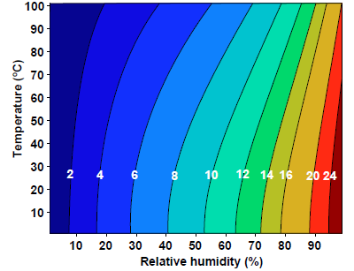

**Fig. 1.7. MC of wood as a function of relative humidity and temperature** (Wood Handbook, 2010)

One of the wood disadvantages is wood shrinking and swelling – wood “breathing”. Wood swells-expands in size when it takes on moisture and shrinks-contracts in size when it gives off moisture. Changes in MC are important because wood changes both its shape and size (Fig.1.12). Also environmental temperature effects the MC of wood. Moreover, wood materials do not shrink or swell significantly in relation to temperature. Many of the challenges of using wood as load-bearing and also non-load-bearing material arise from changes in MC. Some properties are species-dependent, e.g. MC at the same air relative humidity (RH) level of the green pine heartwood lower (~ 40%) and sapwood – higher (90%). MC operationally, is usually expressed as a percentage. Variability of green MC exists even within individual boards cut from the same tree.

#### Methods of determination of wood moisture

The *Electric moisture method* is used as electrical resistance (EN 13183-2:2002) moisture meter (Fig.1.8.A) or capacitance (EN 13183-3:2005 meter (Fig.1.8.B), by measuring the capacity of wood to store energy, the amount of power the wood absorbs from the field (power loss), or the wood’s resistance to the field (impedance). They translate this electrical information to a percentage of MC[3]

|  |  |
| --- | --- |
| A | FMW-B Brookhuis Moisture Meter, Packaging Type: Plastic Box, Rs 41500  /piece | ID: 14901965348B |

**Fig. 1.8. Wood moisture meters by Brookhuis:** A - electrical resistance[4] moisture meter B - capacitance moisture meter[5]

Moisture meters have a max capacity of measuring moisture up to 30%. For dry woods, error possibility is ±2% of MC. This is express method, but not so precise as all below mentioned. And it is the most common used for structural elements. *Oven dry method* is used regarding EN 13183-1:2002, in drying oven with temperature 103±2 °C. There also exist *Hygrometric method* and *Distillation method* which is more suitable for hardwoods and especially for chopped wood.

#### Water Vapour Sorption

When wood is protected from contact with liquid water and shaded from sunlight, its MC below the FSP is a function of both RH and temperature of the surrounding air. Wood in service (operational conditions) is exposed to both long-term (seasonal) and short-term (daily) changes in RH and temperature of the surrounding air, which induce changes in wood MC. These changes usually are gradual, and short-term fluctuations tend to influence only the wood surface. MC changes can be retarded, but not prevented, by protective coatings such as varnishes, lacquers, paints etc.

#### Equilibrium Moisture Content

Equilibrium MC (EMC) is defined as: value of MC corresponding to the given combination of temperature and relative humidity (RH) of the atmosphere. Usually interior for living areas the most appropriate level of air humidity is 65±5%. On this humidity level and temperature 20±3 °C the MC of the wood~ 12±2%. For example, figure 1.9. illustrates what MC in general could be related to temperature.

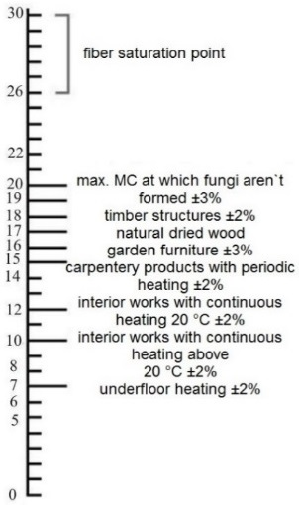 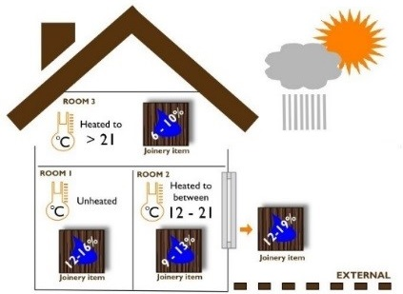

**Fig. 1.9. EMC of wood by its application[6]**

Above is shown diagram of MC for timber materials by its application (Fig.1.9.). In reality, EMC almost never exists because the relative humidity in the air is constantly changing. As RH increases, the EMC is disturbed as the wood starts to absorb moisture from the air. It will settle on a new EMC if the RH stays at that higher level for an extended period. But if RH starts to drop, the wood will give off moisture, MC will drop and EMC will only occur if RH again stops changing, for an extended period. The interplay between RH and MC is almost constant, and the wood is rarely at EMC. That is the reason why wood is constantly moving.

### Density

Density, may be defined as “*mass per unit volume*” or 'volumetric mass density', is the unit weight expressed as kg m-3 (international system (SI)) or g cm-3 or lb ft-3. In contrast to other materials, for wood, both mass and volume depend on MC. This expresses how much one cubic meter of wood weighs. Most commonly the density of wood is given as dry air density, at MC 12% (or 15%) and it varies significantly between species (Table 1.3.).

|  |  |  |
| --- | --- | --- |
| C:\Users\Uldis\Pictures\bl.png | The difference in density in wood from 1918 to 2018 : Damnthatsinteresting | C:\Users\Uldis\Pictures\asdf.png |
| A | B | C |

**Fig. 1.10. Differences in appearance between wood from years 1918 and 2018[7] (B) and distribution of density:** A- pine trunk; C- spruce(Liepiņš, 2019)

Although the oven dry density of most species falls between about 320 and 720 kg m–3, for some species, e.g. iron wood, the density can be more than 1000 kg m–3. In figure 1.10.B it can been seen, that varies not only ratio of early wood to latewood, varies also wideness of annual rings.

Trees can be divided in to the groups:

* Light density (<540 kg m-3) wood - spruce, aspen are examples of wood with a density of 400 and 440 kg m-3.
* Middle density (550 to 740 kg m-3) wood - maple has a volumetric mass density of 600 kg m-3.
* Heavy density (>759 kg m-3) wood is often hardwood - beech with 710 kg m-3, oak 820 kg m-3, ironwood (*Olneya tesota* Gray.) has a density more than 1000 kg m-3.

The most common tree species used in construction in Europe are pine, spruce and oak. For pine grown up in Europe density varies 370 to 550 kg m–3, for spruce 300 to 470 kg m–3, for oak 720 to 850 kg m–3.

Of course growing rate is not influenced by year. If the annual rings are closer and percentage of latewood is higher, than density, as well, is higher. As it can be seen from figure 1.10.B, there are lighter and darker growing ring parts. Cells formed at the beginning of the growth increment are called early wood cells (called springwood), and cells formed in the latter portion of the growth increment are called latewood (called winter wood) cells. In a normal pine and oak tree, for example, the share of summer wood is on average 25% and in spruce about 15%.

The density also various of place in timber (Fig.1.10.A and C). The density of the wood increases with age in species of tree in which the density increases from the core out towards the surface.

### Dimensional stability and shrinking/swelling

Wood is dimensionally stable when MC is greater than the fiber saturation point. Below FSP wood changes dimension as it gains moisture – swells, or loses moisture - shrinks (Fig.1.11.), because volume of the cell wall depends on the amount of bound water.

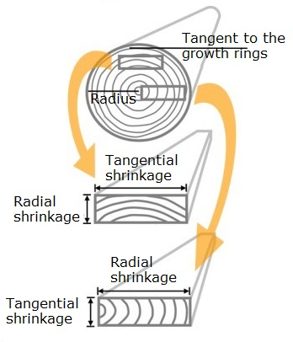 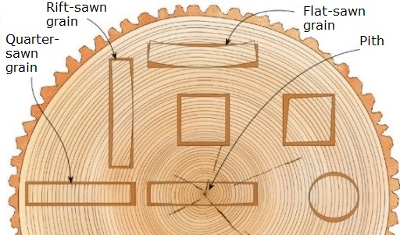

**Fig. 1.11. Sawn material of boards depending on the place in cross section in timber[8] and characteristic shrinkage and dimensional stability of different geometrical wood cross sections[9]**

In general, greater shrinkage is associated with greater density.

Geometrical changes of flat, square, and round pieces are affected by direction of growth (annual) rings (Fig.1.3.). If the growth rings are vertical (Fig.1.11.), the board barely changes in shape at all. That board called radial and shape of it can be found in the central part of cross section of the log. If the growth rings are curved that board called tangential (Fig.1.11.). Shrinking and swelling depending of direction (Fig.1.11.) of wood fibres are followed:

* tangential~ 10%;
* radial little more~ 5%;
* longitudinal or axial – less than 1%.

Longitudinal movement means movement in length. As it is very low it should not be taken into account.

In general, shrinking and swelling can result in warping of wooden boards as well. Figure 1.12. (1, 4 and 7 board) shows geometry of wood boards after sawing.

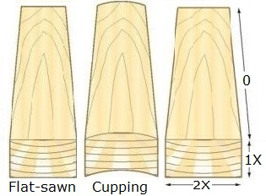 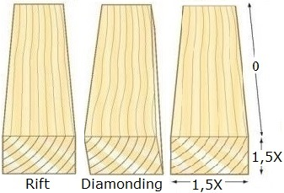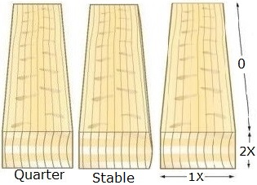

**Fig. 1.12. Board shapes after the sawing/drying and also swelling**[10],[11],[12]

At Figure 1.12. (2, 5 and 8 board) change in shape can be seen after the drying. Flat-sawn materials make cup (Fig.1.12. board 2). Rift-sawn lumber (Fig. 1.12. board 5) becomes a parallelogram as it dries. This phenomenon is known as “diamonding” (Fig.1.12. board 5) because the original rectangular shape becomes more of a diamond shape. It happens, because of MC drops. Increase the MC of the cupped piece of wood and it will start the “uncupping”.

In figure 1.12. shown flat-sawn (3), rift-sawn (6) and quarter-sawn (9) boards and the rate of movement12 The length does not change in any of the three cases (Fig.1.12.), it is not actually zero, but it’s so tiny that it can be safely ignored for construction purposes.

### Wood defects – make influence to structural properties

#### Tree growing defects

Some wood defects also should be taken into account before wood is used for different applications. There are some: dead or loosed knots, splits, compressed wood, reaction wood etc. At the time of growing two key examples of the biology of the tree affecting the quality of wood can be seen in the formation of juvenile wood and reaction wood (Fig.1.13.).

 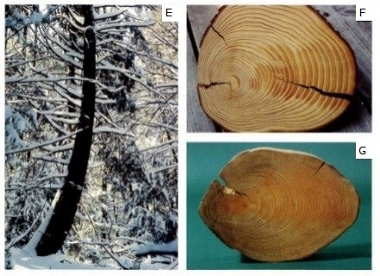

**Fig. 1.13. Macroscopic and microscopic views of reaction wood:** A – compressionwood in Pine;B - tension wood in walnut; C – microscopy of pine compressionwood; D- microscopy of walnut tension wood; E-growing tree; F and G- compression wood (dark patch) (Wood Hanbook, 2010; Hoadley, 2010).

Juvenile wood is the first-formed wood of the young tree - the rings closest to the pith. When the wood is dried, resulting in a piece of wood that has a tendency to warp, cup, and check more. The cells, instead of being long and straight, are often shorter and angled, twisted, or bent.

Reaction wood refers to abnormal wood tissues produced in tree trunks subjected to strong wind pressures. In the softwoods it is compression wood (contains more lignin than normal wood) and in the hardwoods - tension wood (contains more cellulose than normal wood) (Wood Hanbook, 2010). Reaction wood is much denser than normal wood with the specific gravity of around 35% greater in compression wood and 7% greater in tension wood. Longitudinal shrinkage is also greater, 10 times more than normal for compression wood and 5 times for tension wood. Timber containing compression wood is liable to excessive distortion during drying and tends to fail in a brittle manner. It is harder to drive a nail in compression wood, there is a greater chance of it splitting, and compression wood may take a strain differently than normal wood. Most visual strength grading rules limit the amount of compression wood in high quality grades (Wood Hanbook, 2010). *Slope of grain* in an idealized saw log, the cells of the axial system in the wood are parallel to the length of the log. When the long edge of the board is not parallel with the grain, the board has what is called slope or diagonal grain (Fig.1.14.).

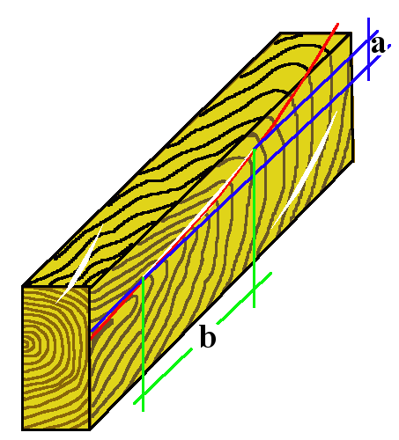 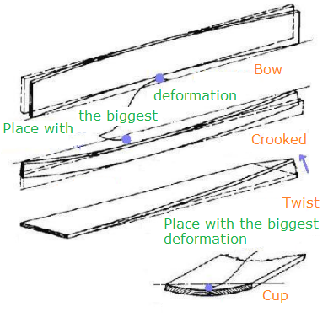

**Fig. 1.14. Slope of grain[13] and unregular shapes of boards:** A – twist; B – bow; C - cup; D – crook[14]

Boards with diagonal grain will show atypical shrinking and swelling with changes in MC. And also mechanical properties changed depending on the slope of grain. Grain deviation can severely impair the strength properties of timber (Table 1.2.)

Table 1.2.

**Effect of grain deviation on strength properties of timber** (Porteaus and Kermani, 2013).

|  |  |  |  |
| --- | --- | --- | --- |
| Slope of grain | Bending strength, % | Compression parallel to grain, % | Impact loading, % |
| Straight grain | 100 | 100 | 100 |
| 1 in 20 (3°) | 93 | 100 | 95 |
| 1 in 10 (6°) | 81 | 99 | 62 |
| 1 in 5 (11,5°) | 55 | 93 | 36 |

That kind of wood defects and above mentioned make boards in regular shape after drying – in the time of exploitation. When the board indicated by curvature formed in direction of length of board (Fig.1.14.) it is called bow. Crooked of the board is the curvature of the piece of sawn wood in the plane of flat-wise (also known as spring or free side bend). If a board has spirally distorted along its length, is known as twist (Fig.1.14.). Cup of the board is indicated by curvature formed in transverse direction of wood.

*Knots*

In wood quality and strength sorting, about 90% of quality criteria are related to its knots. Figure 1.15. shows the beginning or first stage of forming of the knots. At the first stage knot is alive, then after the years it can become dead knot – stage 2 (Fig.1.15.). Tree still growing and dead knot can be closed, which stays under the growing wooden fibers as bark pocket for example (Fig.1.15.) – stage 3.

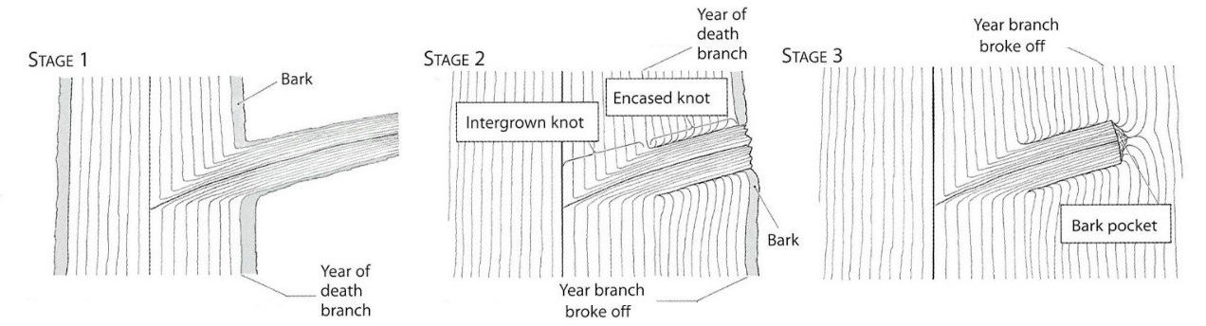

**Fig. 1.15. Forming of knot** (Hoadley, 2010).

Secondly that is look at the standing timber (Fig.1.16.). As it can be seen less branches are located in the lower part of timber. And especially many black/dead branches are in the periphery. Timber without branches is obtained only from the outskirts of the pine trunk. Spruce branches are more or less evenly distributed along the entire length of the trunk. The height of the trunk is from 20 to 30 m.

|  |  |
| --- | --- |
| C:\Users\Uldis\Pictures\890.jpg | |
| A | B |

**Fig. 1.16. Characterization of trunk:** A- pine; B- spruce (Softwood sawn material application. Guidelines. 2009).

Figure 1.17. shows type of knots and also appearance how does they looks like on the boards.

|  |  |  |  |  |  |  |  |
| --- | --- | --- | --- | --- | --- | --- | --- |
| Graphic11 | Graphic11 | Graphic11 | Graphic11 | Graphic11 | Graphic11 | Graphic11 | Graphic11 |
| *live knot* | *dead knot* | *knot with bark* | *rotten knot* | *edge knot* | *wedge branch* | *leafy knot* | *group of knots* |

**Fig. 1.17. Types of knots** (Softwood sawn material application. Guidelines. 2009).

The presence of knots has adverse effects on most mechanical properties of timber as they distort the fibres around them. For example, the presence of a knot on the lower side of a flexural board, being subjected to tensile stresses due to bending, has a greater effect on the load capacity of the member than a similar knot on the upper side being subjected to compressive stresses (Porteaus and Kermani, 2013).

## Mechanical properties

Factors affecting strength of wood:

* density of wood;
* grow ring width and specially percentage of early and late wood;
* moisture content;
* direction of grain;
* temperature;
* time of loading;
* locality of wood defects.

Strength properties of wood increase with its decreasing MC. For example, air-dried wood with average MC of 12% will have higher strength properties than that of wood with 20 or 30% (Table 1.3.). In general, wood is dried to 15 till 20% moisture for typical structural application rather than using it in green condition. Strength properties of wood also can be estimated using some equations.

Table 1.3.

**Mechanical properties of pine, spruce and oak clear specimens**

|  |  |  |  |  |  |  |  |  |  |
| --- | --- | --- | --- | --- | --- | --- | --- | --- | --- |
| Wood Species | Bending strength,  N mm-2 | | Compression strength parallel to grain, N mm-2 | | Compression strength perpendicular to grain, N mm-2 | | Tension strength parallel to grain, N mm-2 | | Density,  kg m-3 |
| MC 12% | MC ≥30% | MC 12% | MC ≥30% | MC 12% | MC ≥30% | MC 12% | MC ≥30% |  |
| Pine | 91 | 49 | 50 | 21 | 7,0 | 5,0 | 95 | 78 | 540 |
| Spruce | 87 | 43 | 39 | 19 | 5,3 | 3,8 | 116 | 77 | 470 |
| Oak | 103 | 66 | 57 | 31 | 10,2 | 7,2 | 140 | 107 | 820 |

### Viscoelasticity

Elastic materials easily stretch under an applied load and return to their original conditions - wood cells help to do it (case figure 1.18.A.) once the load is released and it is called viscoelasticity. Different for applying as shows figure 1.18.B. on right hand side, after load applied sample brakes, because wood cell does not resist.

|  |  |  |
| --- | --- | --- |
| C:\Users\Uldis\Pictures\rthrty.jpg C:\Users\Uldis\Pictures\5644.jpg | | |
| A | B | C |

**Fig. 1.18. Orthotropic structure of wood[15]**

Figure 1.18.C illustrates the viscoelastic behaviour of wood at the time of applying load and after realizing it.

### Compression strength

Compression of wood and wood-based materials play an important role in almost any construction projects. Compression strength should be known for calculation of deformation due to bearing a load, which could even lead to its failure during service life.

Compression may be of two kinds depending on grain direction:

* compression parallel to grain;
* compression perpendicular to the grain.

The compression strength of air-dry wood is about half of the corresponding tensile strength.

Compression strength for wood in direction of fibres or longitudinal axis is the highest, and varies from 25 to 55 N mm-2 (Table 1.3.). In direction perpendicular to grain timber is~ 5 to 7 times weaker and varies from 7 to 15 N mm-2. Principle of load applying is shown in figure 1.19.A.

|  |  |  |
| --- | --- | --- |
| C:\Users\Uldis\Desktop\COMP.jpg | LCT ONE Deckenmontage © DarkoTodorovic | https://inhabitat.com/wp-content/blogs.dir/1/files/2010/10/new-251.jpg |
| A | B | C |

**Fig. 1.19. Compression parallel to grain[16]**

That is why timber in grain direction could be used especially for columns. Figure 1.19.B. and 1.19.C. shows applications of [CREE building systems](https://www.youtube.com/watch?v=ZOaSZTNAjRw&feature=emb_logo). As it can be seen for columns solid wood slabs are used. Also for panel structural elements solid wood beams with high strength class.

### Bending static strength

Two parameters are always determined for bending strength – strength (modulus of rupture (MOR)) and elasticity (modulus of elasticity (MOE)). MOE is measured at the time of load application and MOR is related to maximum strength of a board. These parameters are calculated using stress – force/load on unit area (N mm-2) and strain - displacement/change in length on original length (mm). The modulus of elasticity of wood in the direction of the grain may be up to a 100 times more than perpendicular to the grain.

For general purposes 3 point bending is used (see Fig.1.20.A.), for investigation of structural wooden elements such as sawn materials, beams etc. 4 point bending is used (Fig.1.20.B.)

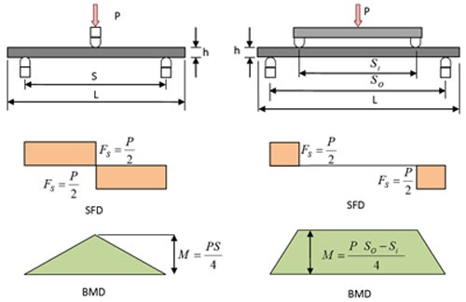

|  |  |
| --- | --- |
| **A** | **B** |

**Fig. 1.20. Three and four point bending of a wood beam:** A- 3 point bending; 4- point bending[17]

In general 3 point static bending for characterization of materials is used and it shows concentrated load. Four point bending usually is used to investigate influence of the wood defects to strength values. This load is showing strip load and beams break always at weakest place. Figure 1.21. illustrates a typical panel bending with deflection as a result of a strip load.

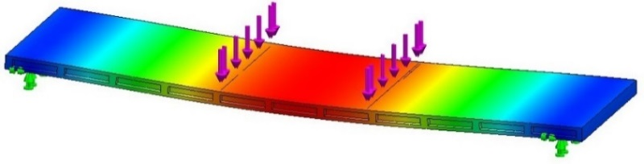

**Fig. 1.21. Modelling of materials at four point bending.**

It can be seen that the maximum load concentrates between upper load supports.

### Tensile strength

Tensile strength in the direction of the grain is usually 10 to 20 times more than perpendicular to the grain (Fig.1.22.). Tensile strength also depends on the density of the wood, for instance, pine spring wood is 6 times lower tensile strength than summer wood.

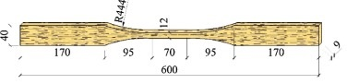`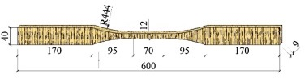

**Fig. 1.22. Wood samples for tensile strength:** A- parallel to grain; B- perpendicular to grain. (Xu et al., 2017)

### Shear strength

In constructions also shear strength is vital. Shear is defined as resistance offered by the wood sample to slipping or sliding of one position upon other.Shear is found parallel and perpendicular to grain, as well (Fig.1.23.).

The shear strength of wood is 10 to 15% of its tensile strength in the direction of the grain. Shear strength is weakened by wood defects - knots and cracks that appear in the wood.

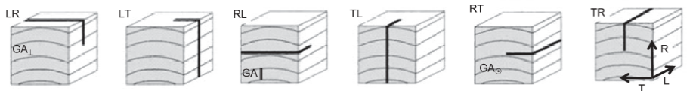

**Fig. 1.23.** **Shear strength.** (Gupta and Sinha, 2012)

### Impact bending, toughness and dynamic properties

Impact bending is defined as, “resistance by a wood sample to certain shocks”, in this case hammer (weight is 8.5 kg) dropped down of height 1,2 meter. The energy (striking energy of hammer) by which the hammer strikes the wood sample and resistance is offered by wood sample called as residual energy. in general, two kinds of energy are present: striking energy, residual energy. For building elements mostly properties of static characteristics should be taken into account except, e.g. regions where the earth quakes often happen.

## Technological properties

Technological properties of wood include hardness, drying, ability to contain metal fasteners, bendability abrasion resistance etc. properties of wood.

### Wood Drying

The stresses that occur in a material without the action of external forces are called internal stress. These stresses occur during the drying process and are the main cause of uneven moisture distribution in wood.

Initially, water evaporates from the wood outer layers. If the MC in the outer layers drops below the FSP, then their shrinkage happens. However, the complete drying of these layers is hindered by the inner, wetter layers. As the MC of the inner layers of the wood decreases below the FSP, it starts to shrink. If the tensile stresses between layers reach the ultimate tensile strength of the material across the fibers, then cracks appear: at the beginning of drying on the wood surface, at the end of drying - inside it. Internal stresses also persist in the dried material and cause size and shape changes during machining of it. These stresses are determined by "force sections" and can be investigated if sample in a distance of 0,5 m from the end of the board is sawed. Their width and height are determined by the dimensions of the board, but the length 10 to 15 mm. If the members of the section remain parallel to each other immediately after sawing, it means that there is no internal stress in the wood. If the members of the section bend outwards, then the board from which the sawn section has tensile stresses in the outer layers and compressive stresses in the inner layers. If bends inwards – opposite. The internal stresses retained in the material can be decreased, not removed, using surface moistening with water vapour or smoothly with a water.

### General overview of sawing wood materials

In sawing practice logs are cut in the middle, splitting the pith of the wood. In the case of the usual type of sawing, the edges of the log are cut off from both sides first. The resulting log is turned to the flat side, sawn into the central materials and side boards with rectangular shape (Fig.1.24.).

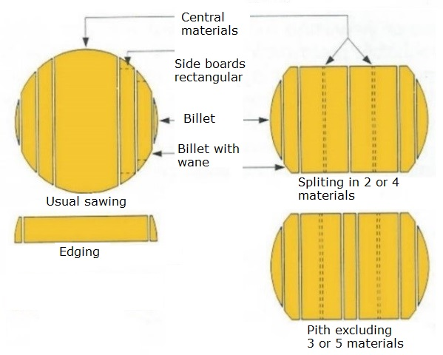 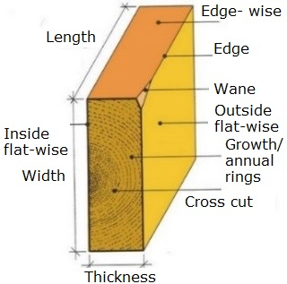

**Fig. 1.24. Sawing plan characterization of sawn materials, terminology of the board** (Softwood sawn material application. Guidelines., 2009).

Sawing of timber could be realized by several technics: bend-saw; saw-frame; disk-saw. Sometimes it could be combined with milling machine which chipping side pieces of timber or slab. Used technics with the cutting tools leaves raw surface (Fig.1.25.). Nowadays for sawing of the boards mostly bend or ripsaw technologies are used. It takes less energy and less wood losses, because of cutting width 4 to 5 mm of sawing instrument, instead of frame saws 7 to 8 mm.

|  |  |  |  |
| --- | --- | --- | --- |
| Graphic9 | Graphic7 | Graphic8 | Graphic8 |
| saw-frame sawing | bend-saw sawing | ripsaw sawing | milling machine used |

**Fig. 1.25. Sawn material surface characterization.**

Afterwards the sawing boards are switching to visual grading. Boards have following parts with following names (Fig.1.24. on the left hand side) According to some European standards it is possible to find out exact quality of round timber.

## Operational properties

### Thermal characteristics

The thermal conductivity of wood is relatively low because of the porosity of timber (Fig.1.26.). It is one of the properties due to which timber is used as building material. More about thermal conductivity is shown in LU4.

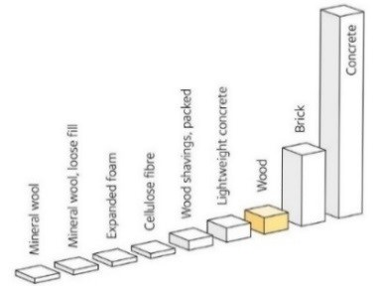

**Fig.1.26. Thermal conductivity of different construction materials[18]**

### Nail or screw resistance

It may be defined as resistance offered by the wood to withdrawal a nail or screw from its surface which depends on its position in relation to the direction of the fibers, wood density and MC. If nail is driven in the direction of the fibers, then its withdrawal force requires 20 to 50% less force than such for pulling the nail driven perpendicular to grain. The higher density of the wood the more difficult to withdraw a nail or screw. For example, nails need to be driven in or withdraw of beech (ρ12= 730 kg m-3) with four times greater strength than pine (ρ12= 440 kg m-3). As the MC of the wood increases, it becomes easier to drive in the nails. Shape of nail or screw and also the depth of nail driven into the wood also make influence on it. Wood withdrawal capacity of the screws are about twice higher than withdrawal capacity of the same size nails. More about this topic is described in LU2.

### Hardness of wood

Hardness is defined as, “the resistance offered by the wood to indentation (to make a dent)”. Resistance is checked against a hard steel rod called as *Janka* which is the type of electronic device. There can be measured static and/or impact hardness. Static hardness is determined by a ball which diameter is chosen by calculation so that its pushing-in section area would be 1 cm2. For hardwoods the hardness in the radial and tangential direction is 30% and for softwoods is 40% lower than cross-cut section. As the MC of the wood increases the hardness decreases - for each percentage point of MC~ 2 to 3%. Depending on the end surfaces hardness all timber species are divided into three groups: soft hard <40 N mm-2; middle hard 40.1 to 80 N mm-2 and very hard > 80 N mm-2. Table 1.4. shows some values.

Table 1.4.

**Hardness by wood species**

|  |  |  |
| --- | --- | --- |
| Wood Species | Hardness, N mm-2 | Density, kg m-3 |
| MC 12% | |
| Pine | 29/14 | 540 |
| Spruce | 26/12 | 470 |
| Oak | 68/40 | 820 |

### Abrasion resistance of wood

Mechanical forces (mainly friction) on wood such surfaces as floors, stairs, thresholds, etc. wears down. The abrasion resistance of wood characterizes its top layer abrasion resistance, e.g. frictional collapse. For the determination of abrasion resistance use methods where the test conditions are as close as possible to the wood operating conditions for above mentioned surfaces. Abrasion resistance is measured in mm and g (after loss of mass). As the density and hardness of wood increases, its weariness decreases.

### Sound velocity

There exist different measurement systems (Fig.1.27.) for detection of wood cavities, cracks and decay in its early stages including brown and white wood decay. These instruments provide easy and fast wood quality measurements for wood inspection based on the speed: it takes a sound impulse to travel through the wood material and also standing tree as well (clearly displays the interior conditions of a tree). It can be used for tree care and inspection to maintain safe parks, roadways and forests to detect remaining wall thickness of a tree.

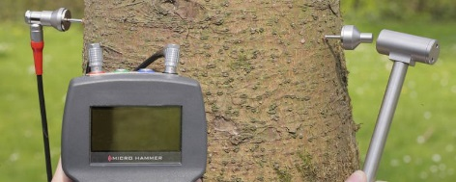

**Fig. 1.27. Sound velocity measurement system[19]**

# LIST OF REFERENCES

1. EN 13183-1:2002 Moisture content of a piece of sawn timber. Determination by oven dry method.
2. EN 13183-2:2002 Moisture content of a piece of sawn timber. Estimation by electrical resistance method.
3. EN 13183-3:2005 Moisture content of a piece of sawn timber. Estimation by capacitance method.
4. Gupta and Sinha. Effect of grain angle on shear strength of Douglas-fir wood. 2012., DOI:10.1515/hf-2011-0031Hoadley R.B. Understanding wood. The Taunton Press, China, 2000., 280 p.
5. Hodley R.B. Understanding Wood: A Craftsman's Guide to Wood Technology. The Taunton Press; 1st edition, 2000., 288 p.
6. Liepiņš J. Methodology development for forest stand biomass and carbon stock estimates in Latvia, doctoral thesis, LLU, 2019., 60 p.
7. Softwood sawn material application. Guidelines. (Skujkoku zāģmateriālu pielietošana. Vadlīnijas. In Latvian). 2009., ISBN/ISMN 978-9984-39-720-7.
8. Theapparat Y., Chandumpai A. and Faroongsarng D. Physicochemistry and Utilization of Wood Vinegar from Carbonization of Tropical Biomass Waste. DOI: 10.5772/intechopen.77380
9. Wertheimer D. Moisture & Wood Movement. How To & Calculators, 2019., https://www.branchingoutwood.com/blog/wood-movement-and-moisture.
10. Wood Handbook, **Robert J. Ross**. Forest Products Laboratory USDA Forest Service. 2010, https://www.fs.usda.gov/treesearch/pubs/37440
11. Xu M., Cui Z., Chen Z. and Xiang J. Experimental study on compressive and tensile properties of a bamboo scrimber at elevated temperatures. Construction and Building Materials, Volume 151, 2017, pp. 732-741.

1. <https://www.thinkwood.com>
2. <https://careforwood.wordpress.com/wood-anatomy/>
3. https://www.moisturemeters.com/moisture-meter-technology/
4. https://www.brookhuis.com/wood-testing/moisture-content/moisture-content-handhelds/handheld-fmd6/;
5. https://www.brookhuis.com/wood-testing/moisture-content/moisture-content-handhelds/handheld-fmw-b/
6. <https://www.wooduchoose.com/BlogPost/?Moisture-Content-of-Wood>
7. <https://www.reddit.com/r/Damnthatsinteresting/comments/fbhmw1/the_difference_in_density_in_wood_from_1918_to/>
8. <https://www.workspacetraining.com.au>
9. [https://www.woodcraft.com/blog_entries/how-to-air-dry-lumber-turn-freshly-cut-stock-into-a-cash-crop-of-woodworking-woods#](https://www.woodcraft.com/blog_entries/how-to-air-dry-lumber-turn-freshly-cut-stock-into-a-cash-crop-of-woodworking-woods)
10. <https://www.canadianwoodworking.com/get-more/wood-cuts-and-how-they-react-moisture>
11. <https://www.canadianwoodworking.com/get-more/wood-cuts-and-how-they-react-moisture>
12. <https://www.canadianwoodworking.com/get-more/wood-movement>
13. <https://commons.wikimedia.org/wiki/File:Slope_of_grain_on_board_beentree.png>
14. <https://20d54786-a-62cb3a1a-s-sites.googlegroups.com/site/leonardoguitarresearch/glossary/Eng%20-%20Deformations.png?attachauth=ANoY7cpapMBSW-3jG8m2jTfvC0iWvOV2qhpRFY_6NjGeyQ5k9rnYg7qjkoj6p7ElcN3HaESI3-yCK9ZVQ-blXo_CeNBUmtt8TG-OSd3CbYG5ygBmqDLpz_3sy2ED1R4tNuMOPe0pjeUr8V82WpbNzWs6q_RP7iJ95pFDwuFXNibm_sE1-hsmLKqeKHr1AtS03ymwZvOPvIA51S0ZBoZNLJkgTklHStCakbNZS18oGgCPxu1uYCffzXRks-zjdcuNxPOtH9r7GCMq&attredirects=0>
15. <https://extension.okstate.edu/fact-sheets/strength-properties-of-wood-for-practical-applications.html>
16. <https://www.buildup.eu/en/practices/cases/lifecycle-tower-one-building>

    <https://inhabitat.com/lifecycle-tower-in-austria-will-be-worlds-tallest-wooden-building/new-25-8/>
17. <https://nptel.ac.in/content/storage2/courses/101104010/lecture39/39_6.htm>
18. <https://www.swedishwood.com/wood-facts/about-wood/from-log-to-plank/properties-of-softwood/>
19. <https://www.iml-service.com/sound-velocity-measurement/>