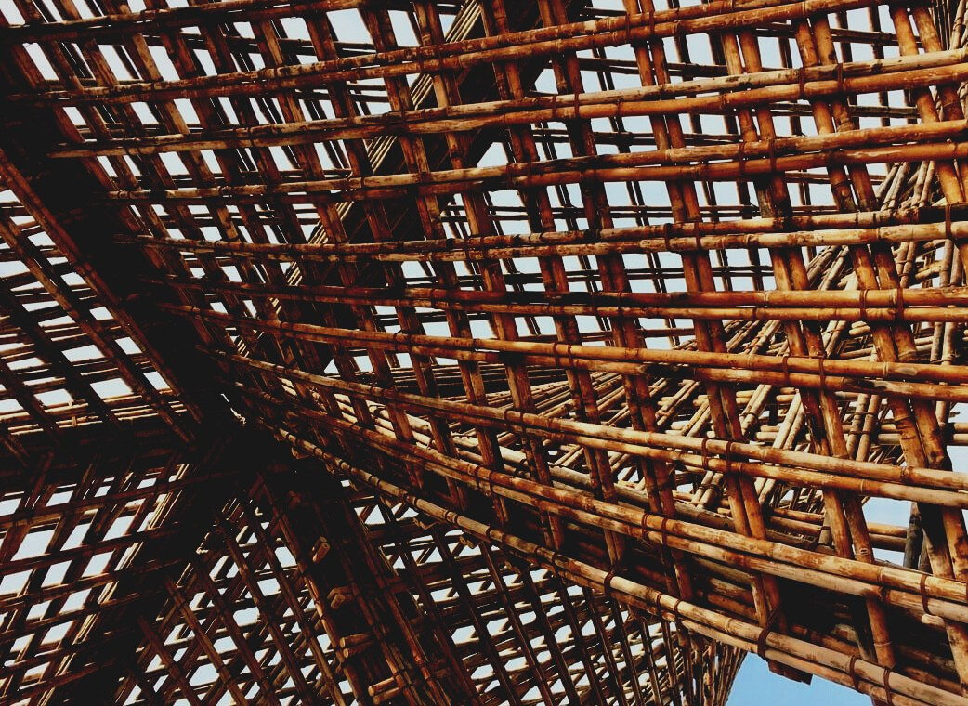

TRAINING MATERIAL

Learning Unit 2
RESTORATION, RECONSTRUCTION AND DISMANTLING
UPWOOD
Up-skilling construction workers in wood construction methods for energy-efficient buildings

UPWOOD-PUU
Rakennustyöläisten ammattitaito energiatehokkaiden rakennusten puurakentamisenmenetelmissä

Table of contents
1. Introduction 2
2. Design of wooden structures 2
3. Life cycle of wood material 3
4. Life cycle calculation 4
5. Building renovation 4
5.1 Renovation 4
5.2 Renovation perspectives 6
6. Repair of wooden parts of the building 7
6.1 Bottom 7
7.2 Midsole 7
6.2 Upper sole 8
6.3 Outer wall 9
7. Repair of outer lining 9
8. Roof 10
9. Windows 10
10. Wooden doors 11
11. Dismantling 11
12. List of references 14

Introduction
The success of energy-efficient and sustainable construction requires special attention in design, production, and construction work. The EU has introduced challenging targets for reducing greenhouse gas emissions and recycling materials in the construction sector, as well as rising energy prices and austerity measures in both production and post-construction housing. It is clear, therefore, that the design and production of future and existing buildings requires extensive cooperation and far-reaching life cycle thinking from authorities, designers, builders, and material and product manufacturers.

Design of wooden structures
In 1975, based on Article 95 of the Treaty establishing the European Economic Community, the Commission of the European Communities adopted an action program in the field of construction technology aimed at removing technical barriers to trade and harmonizing technical requirements. In the framework of the action program, the Commission took steps to harmonize the technical rules for the design of wooden buildings and civil engineering works as an alternative to, and eventually replace, the national legislation in force in the Member States. For 15 years, the Commission, assisted by a steering committee composed of representatives of the Member States, led the development of the Eurocodes program, and the first generation of Eurocodes was completed in the 1980s.
In 1989, the Commission and the EU, and the EFTA Member States decided to entrust the preparation and publication of Eurocodes to CEN, with a view to giving them the status of a future European standard, which integrates Eurocodes into virtually all Council directives or Commission decisions on European standards.

Life cycle of wood material
Life Cycle Assessment (LCA) is a method of determining the environmental impact of a product or service throughout its life cycle. The complete life cycle consists of sourcing the material from nature, handling and transporting the material, manufacturing, distributing, using, reusing, servicing, recycling, and disposing of the product.
The life cycle of a wood product begins in the forest or on the farm where the tree grows. About 30 tree species grow wild in Finland. The life cycle of a wood product is affected by the choice of materials, the life of the product, and the recycling of the product after use. Durable material is usually an environmentally friendly choice. Wood can withstand unprotected time and mechanical stress only if it stays dry.
The less wood has been treated, the easier it will be to find a new use. The solid wood material is well suited for recycling, as long as the surface treatment does not cause problems. The downside to recycling materials is that the quantity, quality, and size of the material affect what can be made from the material.
Forests affect the earth's climate. Tree biomass consists of water, nutrients, and carbon.
Carbon comes from atmospheric carbon dioxide, which is why the world’s forests act as a major carbon sink and curb greenhouse effects and global warming. Carbon n is committed not only to wood but also to wood products and structures. For example, a log house stores coal for up to several hundred years. At the same time, a new wood store has grown in the forest that has sequestered carbon. If the wood structure can no longer be reused after the end of the initial need for use, it can be converted into thermal energy by burning.
Environmental efficiency and life-cycle economy do not yet have a decisive influence on construction decision-making. In the future, the competitiveness of wood concerning other building materials will be examined primarily over the life cycle of the building.
In terms of life cycle economics, the environmental performance of wood and the versatility of premises, as well as the comfort of living, play an important role in the construction and real estate business.

Life cycle calculation
The calculation of greenhouse gas emissions during the life cycle of buildings will become mandatory in Finland in office and apartment buildings and public buildings even before 2023. New buildings are usually so energy efficient that the share of building materials and methods is emphasized. In addition to the carbon footprint, the life cycle calculation considers its opposite carbon handprint, i.e. emission reductions, which are only realized if the building is built.

Building renovation

Renovation
Wood offers diverse architectural possibilities. It is suitable for renovation construction due to its fast and dry construction method, easy fastening and joining technology, lightness of the material, and its winter construction possibilities.
Renovation of the façade of suburban apartment buildings is usually done when the façade is in such poor condition that it is recommended to demolish the old concrete exterior wall. A new foundation wall will be made next to the old foundation wall, on top of which wooden façade elements will be installed.
Facade elements are heavy-duty wooden elements and are made into non-load-bearing structures. When designing an element, it is important to make sure that it is installed tightly against the old concrete element. Facade elements are attached to the inner or outer shell of concrete elements. If the fastening is made to the outer shell of a concrete element, its suitability as a fastening base in terms of strength technology must be ensured. The fastening should be such that the verticality of the facade elements can be adjusted. The façade elements are attached to the concrete frame from the joints between the wooden elements and, if necessary, also from the middle area. The elements can be designed so that they rest on each other, in which case the brackets must be able to withstand the horizontal loads (wind loads) caused by them.
An additional wooden floor can be built of residential elements for residential apartment buildings. The construction of one additional floor as a wooden building on top of a stone-framed building and the same deformation of the roof can improve the look and architecture of a suburban apartment building. A whole new kind of grip and variety can be brought to massaging. In connection with the additional floor, it is also possible to bring naturally new house technology to the water roof, such as solar panels and collectors, as well as ventilation installations. The additional layer can be implemented with any timber frame system.
Construction of an additional floor will begin with the demolition of the old upper floor structure. The midsole consists of top concrete slabs and platform floors with frame beams in old concrete structures. If necessary, a grate is made of steel or wooden beams on top of the old top slab, on which an additional layer is built. The outer walls of the additional layer are the frame or CLT-framed wooden elements and can be load-bearing or non-load bearing. the load-bearing walls of the additional layer are placed in the same places as the load-bearing walls of the lower concrete frame. Due to the stability of the additional layer, stiffening panels are required in the outer walls or diagonal stiffeners in the column frame.
The walls of the apartments are double-frame wooden and CLT-structured wooden elements. The load-bearing walls between the apartments will be placed in the same places as the walls between the apartments in the concrete frame below. The top floor is most sensible to implement with wooden elements that rest on the load-bearing walls and the pillar-beam frame. The upper floor elements must not be continuous from one apartment to another due to the lateral displacement of the sound. Due to the stability of the additional layer, the upper base elements require a stiffening plate on the lower and upper surfaces of the element. The slope and shape of the roof (brush or pulpit ceiling) are made by changing the shape of the top edge of the load-bearing walls. In terms of energy efficiency, the U-value of the beams of a wooden element can be easily modified by changing the height of the beams of the element. The load-bearing structure of the upper sole can also be made of CLT plates.
An additional layer can be built of a wooden space element. Wooden space elements are quick to install, which brings economic benefits. The installation speed and advanced pre-fabrication gun also guarantee better moisture management during construction. The aim is to implement the space elements so that the load-bearing structures of the additional layer are in the same place as the load-bearing walls of the lower concrete frame. The space element always contains a subfloor structure, which can act as a large element in the frame beam of a platform floor.

Renovation perspectives
Most of the repairs are alterations, a small portion is damage repairs. The repair will be cheaper and the better the historical value of the house will be preserved the less is done. You should carefully consider which changes are worth the price. If the house seems to need a complete renovation, replace the house rather than repair it to death. The more material is removed, the more historical value is lost. Reconstruction of a previously demolished part can improve the appearance of the house but does not increase its historical value. A good memory rule can be considered: “Do not repair a good one, do not repair a new one”. The repair must also be repairable, i.e. do not use solutions that are impossible to remove later.
Additional insulation has been a key goal in renovation construction in recent years. The calculations were made on the wrong grounds, but the notion of the usefulness of additional insulation has stuck in my mind. We can only deduce how many chipboard walls were built in the name of additional insulation. Checking and possibly improving the wind protection must always be done when renewing the outdoor board. The windscreen must be sufficiently breathable, i.e. the moisture which has penetrated the inside of the structure must be allowed to evaporate.

Repair of wooden parts of the building

Bottom
The wood structure is more easily damaged than, for example, a concrete structure. It is prone to rot damage, the worst of which is my floor sponge. Insects also cause damage. Moisture damage can cause loss of load-bearing capacity in the structure and this can be caused by pipe leaks inside the structure or water leaks from overhead wet spaces. Thermal insulation regulations make the moisture technical implementation of the structure difficult. A wooden structure is more permeable to air than a stone structure and therefore more difficult to make completely airtight.
Compensating air running inside from under the house creates traction. This is usually due to low or depressed insulation in the floors. The best way to fix the problem is to open the floor and fix the depressed space. If the insulation thickness of the subfloor is small, insulation must be added above or below the floor.

7.2 Midsole
A new midsole will be built to replace the dismantled midsole. New midsole beams and beam extensions should hit the support. The collars are attached to the beams according to the collar division. Removal of the subfloor must not present a risk of collapse or breakage in the building frame and subfloor slabs. During the construction period, the structures will be maintained in terms of load-bearing capacity and appearance in accordance with the plans by using temporary supports and support structures, as well as demolition methods suitable for the site and demolition waste treatment and transfer methods.

Upper sole
Moisture-damaged substructure, underlay, and wooden parts are dismantled. The wood part damaged by moisture is completely removed and both the healthy wood is sufficient (approx. 300 - 600 mm) so that the progression of decay is prevented.
The wooden parts of the water roof substructure and the underlay will be renewed with materials in accordance with the roof supplier's instructions. The requirements of the construction plans shall be complied within the construction of load-bearing structures or parts thereof of the wooden roof of the water roof and in the stiffening of the frame. The working and fastening methods used must not impair the quality of the base, timber or frame accessories, fasteners, or the finished frame. If impregnated timber is used, post-impregnation processing is avoided. According to Class B, impregnated timber must not be processed after impregnation. The moisture content of the timber must not deviate adversely from the final equilibrium moisture content.
Fasteners should be sized so that they do not split or damage the timber. If threaded fasteners are used, the fasteners are positioned so that tightening is possible later as the wood dries. If tightening is not possible, timber with moisture content lower than the final equilibrium moisture when fastened is used.
Those parts of the frame that come into direct contact with moist aggregates are insulated from their substrate. Holes and notches that weaken the structure must not be made in the frame structures without the permission of the structural designer. Any holes, notches, etc. are protected from moisture and, if necessary, heat. Before starting the installation of frame accessories, the various stages of the installation work and the factors that affect them are reviewed. The frame is protected from harmful moisture during installation.

Outer wall
In the façade, the repair considers the compatibility of the materials as well as the suitability for the object and the working method. The aim is to select materials from the same product family. Facade repair can be a matter of partial refurbishment of the facade cladding, cleaning of the paint surface, and painting.
If the façade is renovated, new cladding boards or panels will be used as new cladding boards or panels, preferably spruce sawn cladding boards or panels. Stainless or hot-dip galvanized nails are used for nailing. Upholstery boards meet the requirements of quality class B.
There should be a ventilation gap behind the wooden facade. In vertical boards, under the mounting brackets, baseboards or platform pieces are installed to ensure the operation of the ventilation gap in the outer wall. The joints of the horizontal boarding are made with butt joints so that the seam is tight on the outside.

Repair of outer lining
The condition of the outer lining depends on the air direction, on the sunny side the boards crack, in the shade they last. The need for repairs is therefore not the same throughout the house. On a planed and fine-sawn wall, the modern rough-sawn board looks lousy. On the other hand, too smooth a board in the middle of a shaken wall also does not look stylish. If one or two facades are being completely re-boarded, it is a good idea to save the best-demolished boards for repairing the other walls. Renovated facades improve the wind tightness of the wall by adding tar paper or porous fiberboard under the boarding.
If the façade surface is painted during renovation, there is no need to rush with the surface treatment. There are various resins in the conifer tree that should be allowed to evaporate in peace.
In place of the dismantled load-bearing partition, a new load-bearing partition or pillar-beam structure will be built in accordance with the construction plans. The feasibility of structural plans, e.g. the connection of a new load-bearing structure to the old frame system, is verified by the designer after demolition work.

Roof
In addition to the cover, the substructures may need to be repaired. There are often rotten spots at the base of the barrel, miters, and eaves. The most critical point in the chimney is it’s joining the roof patch, and this point is most often leaking. Usually, repairing the boarding is enough, but if there is rot damage in the rafters, there is more extensive repair work on the load-bearing structures ahead.

Windows
The suitability of new or used timber for use in window repair (suitable dense timber) must be ensured and that a water-resistant adhesive is used for fastening, as well as new tight joints of wooden parts. Putty repairs ensure that the putty is firmly attached to the substrate and leveled at an angle of about 45 degrees. When refurbishing windows, the window frame is removed from the frames and transported to a carpenter's workshop or a refurbishment work area on-site. A light painting repair can be done on site without removing the frame. When refurbishing windows, it is ensured that the jointing compounds or paints removed during the refurbishment of the windows do not contain PCBs, or asbestos.
Poor lumber and paint that makes the surface too hard, inflexible and non-breathable will cause window renovation work. Today, synthetic paints are used, they are easy to use and form a very hard surface that wets away a few years away when maintenance painting is required. If there is major rot damage to the window or frame, check that it is not due to the environment. There may be several causes, the eaves leaking, the molding may be loose, or a nearby tree or shrub may keep the window wet.

Wooden doors
Renovating doors often involves removing and repainting old layers of paint. The door panels to be refurbished are removed from the frames and transported to the carpenter's workshop or the site's refurbishment workspace. A light painting repair can also be done on-site. When painting, attention should be paid to the fact that the newly used timber is suitable for use in the door. The waterproof adhesive is used for fastening. After the repair work, it is ensured that the fastening of the new parts is stable. Exterior doors often also have rot damage, usually at the bottom and in places where the scale has accumulated water. A small rot should not be repaired, but proper hinges should be secured.

Dismantling
First of all, an inventory of substances that are hazardous to health (e.g. asbestos) must be made at the site. Soil and building materials that are hazardous to health will be removed to the extent required by the study and documentation.
If unidentified material is found at the site in connection with the demolition work, the demolition work is suspended, the material is identified, and the material is dismantled as required by the substances it contains. Demolition waste generated at the job is collected and sorted at the worksite into garbage bags or containers and transported to garbage pallets or containers. Dispose of in accordance with local environmental authority guidelines. Conventional demolition waste is usually transported to a landfill and danger Demolition waste generated at the job is collected and sorted at the work site in waste bags or containers and transported to waste pallets or containers. Dispose of in accordance with local environmental authority guidelines. Usually, conventional demolition waste is transported to a landfill and hazardous materials to a hazardous materials collection point. Excavated land is treated as outlined in the planning documents, usually, soil containing construction waste is transported to a landfill and clean soil can be reused in off-foundation backfilling. Waste and soil transport documents are attached to the site documents.
All damaged structures are dismantled from the subfloor and the subfloor is completely dismantled. Demolition of a building component or product should be planned in such a way that its reuse and re-use is a priority, recovery as energy waste is secondary and the supply of material to mixed waste is only a last resort. However, parts and materials that are wet, contaminated, contaminated, or contain contaminants should not be recycled and should be disposed of properly.
The aim is to remove the parts intact and clean and to sort and store them in the shelter for recycling. Useful parts and materials can be used in later jobs yourself, saving money and the environment - making a new product always consumes natural resources and energy. If not all parts or materials are needed, they can be delivered to recycling centers or waste stations, which usually receive used building parts and materials from private individuals free of charge. Parts and materials can be sold to recycling companies or private consumers, e.g. online.
When using demolition material, it should be noted that old or demolished material often cannot be used as such in new construction. In renovation construction, the starting point is that the use of old material must not compromise the safety or health of users. Materials used outdoors are generally not recommended for indoor use.

List of references
Majala, J. 2019. Tuuletettavan alapohjan ilmavuotojen korjaus. Viitattu 2.1.2021. Seinäjoen ammattikorkeakoulu. https://www.theseus.fi/bitstream/handle/10024/171252/Majala_Janne.pdf
Rakennusteollisuus website [referred 23.10.2020]. Available: https://www.rakennusteollisuus.fi/
SFS-EN 1995-1-1 + A1 + A2 + AC. Design of timber structures. Helsinki: Finnish Standard Association SFS ry
Kaila, P. Talotohtori. 1997. Helsinki: WSOY
Ratu KI-6019. Korjaustöiden laatu KTL 2011. Rakennustieto Oy. Tampere: Tammerprint Oy
Rinne, H. Perinnemestarin Remonttikirja. 2010. Helsinki: WSOY
Joint website of Finland’s environmental administration [referred 2.1.2021]. Available: https://www.ymparisto.fi/en-US
Tolppanen, T., Karjalainen, M., Lahtela, T. & Viljakainen, M. Suomalainen puukerrostalo. Rakenteet, suunnittelu ja rakentaminen. 2013. Puuinfo. Tampere: Juvenes Print – Suomen Yliopistopaino Oy
Rakennusten elinkaarilaskenta tulee. Referred 11.12.2020. https://www.tekniikkatalous.fi
Paperin perilliset. Referred 13.11.2020. https://www.tekniikkatalous.fi
Vuotilainen, M., Möttönen, Luostarinen, K., Haapala, A., Kiilunen, R., Etelä, R. & Laitinen, E. Metsästä tuotteeksi, Puualan perusteet. 2018. Tampere: Juvenes Print – Suomen Yliopistopaino Oy

