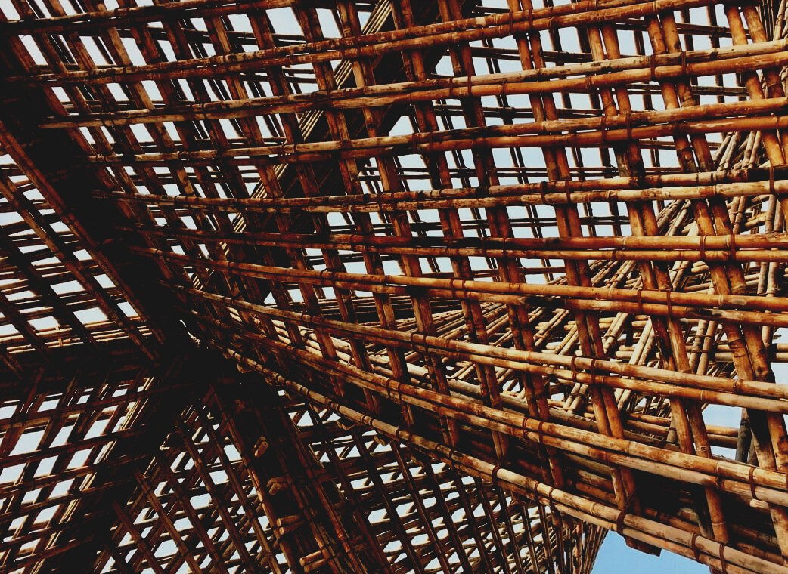
0

UPWOOD
Up-skilling construction workers in wood construction methods for energy-efficient buildings

UPWOOD
Up-skilling construction workers in wood construction methods for energy-efficient buildings

TRAINING & ASSESSMENT
MATERIAL

Learning Unit 3
- Lesson 5: Building physics, installing of vapour barrier and risks of the resulting condensation.

CONTENT
1. CONTENT 1
2. INTRODUCTORY PARAGRAPH 2
3. INTRODUCTORY CONCEPTS 3
4. SHORT VAPOR BARRIER 3
5. LIST OF REFERENCES 10

INTRODUCTORY PARAGRAPH
One of the most important topics to have in consideration when building any residential construction, is the proper adequation of interior spaces, as will be seen in the following units. This adequation involve mostly concerns related to temperature and humidity, and the way to adequate the interior temperatures in contraposition to the exterior temperatures. The difference of temperature can sometimes be broad, producing a delicate point on the closures section, due to the condensations that this temperature difference will carry.
This condensation can be harmful for some of the materials since they may not be prepared to be in contact with water. For this reason, an adequate disposition of the vapour barriers must be carried, to provide the best durability of all the materials composing every closure.
In this topic, a review of the best practices on installing the vapour barrier are considered and detailed, in order to provide the professionals with the best practice guides.

INTRODUCTORY CONCEPTS
Vapour permeability is a material property, expressed independently of material thickness, in units of ng/Pa s m, and given the symbol, µ. Vapour permeance is a measure of the ease of vapour flow through a material layer, in units of perms (equal to 1 ng/Pa s m2 or 1 grain/(hr·in Hg· ft2 )) and given the symbol M. Permeability and permeance are analogous to thermal conductivity and thermal conductance respectively. Imperial US perms can be converted to metric perms by multiplying by 57.1.
Vapor diffusion flow through a wall may need to be controlled with vapor resistant layer in some special cases, but plastered strawbale walls usually don’t need them, and often appear to perform much better without them.

SHORT VAPOR BARRIER
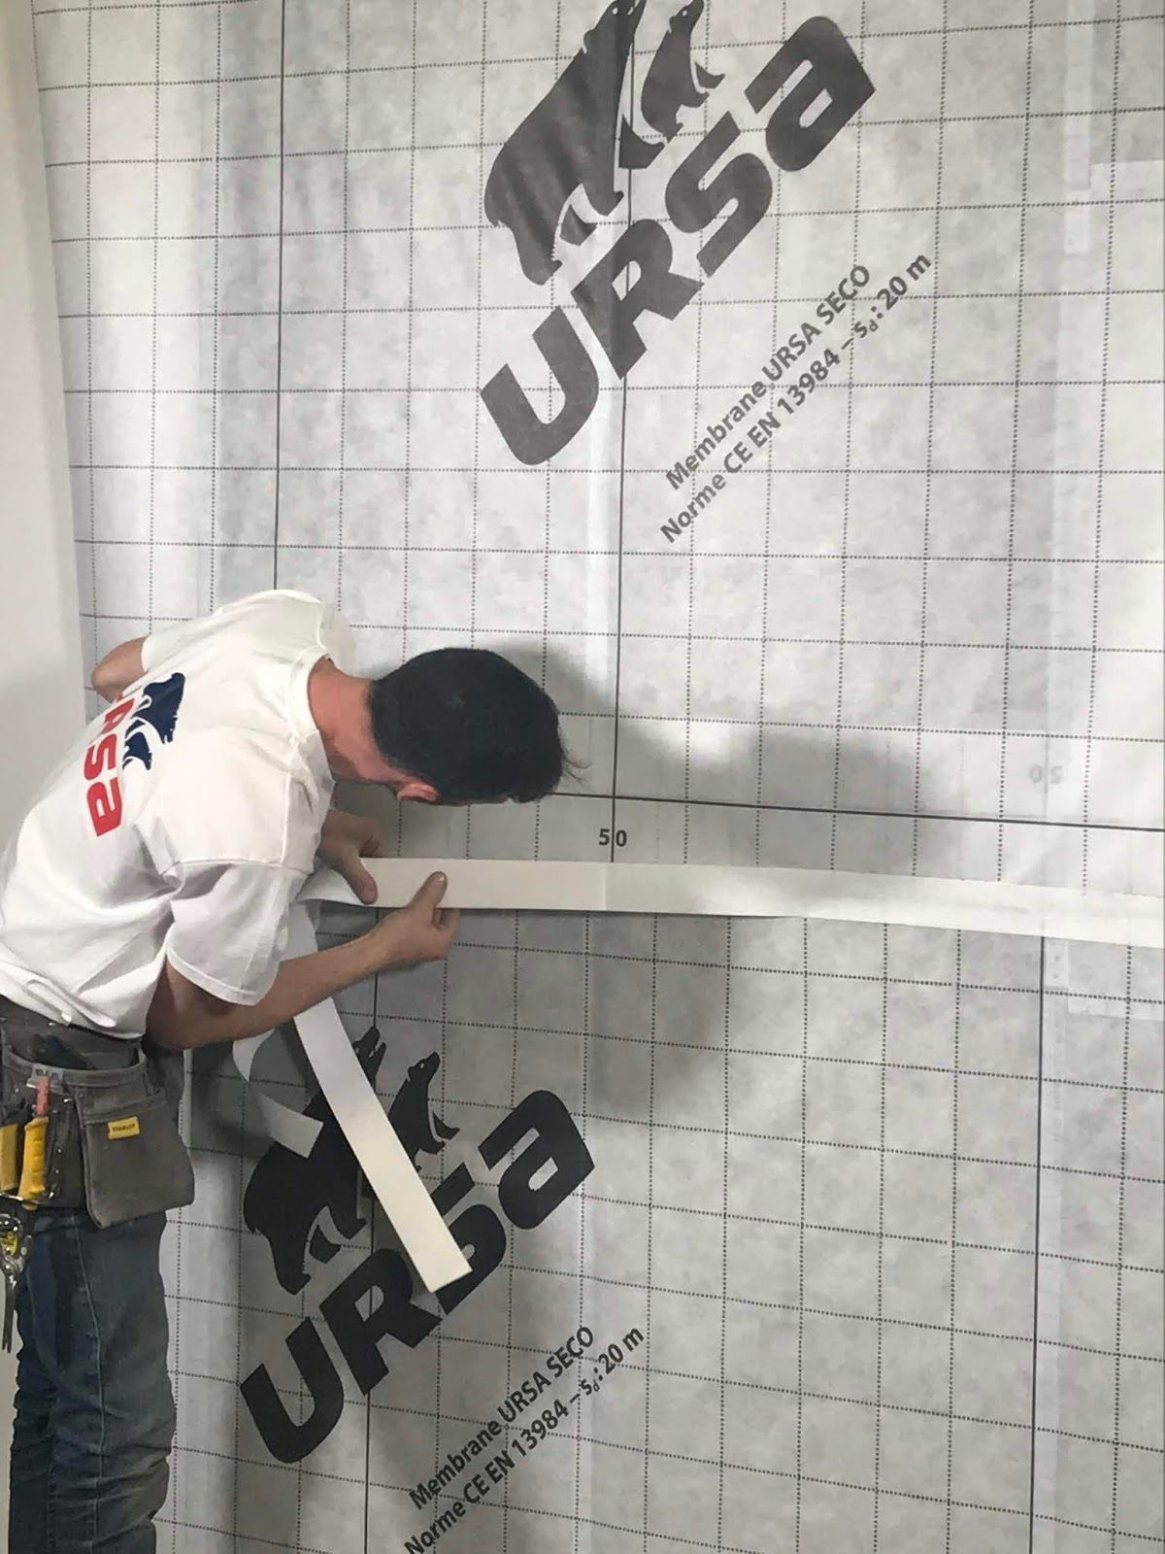
When in a project wood is involved, there are some considerations to acknowledge that are particular for this kind of material.
This material allowed the passage of air and at the same time absorb a large amount of water, these aspects must be considered during the installation of the short vapor barrier.
The consequences of not considering the behaviour of wood can cause:
- swelling of walls,
-collapse of the building due to the increase of
Source: web 2
density of the wood
- problems with the finishing coat and cladding of the walls
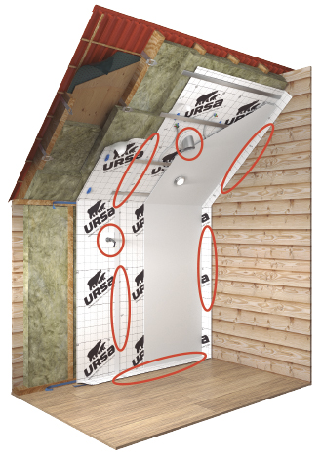
- mold at the corner of the building
- deformation of the walls due to cracking and freezing water
- absorption of humidity by the isolation material and consequent destruction of it.
All this consequence can be prevented with a short vapor barrier executed immediately after the finishing material and joined firmly with the isolation material.
There are different construction materials available such as plastics, film membrane, fillers. Source: web 2
Dry technology
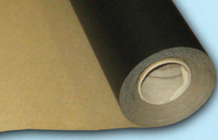
Polyethylene film
Usually are used with a thickness of 1 mm and are the most simple and cheap option. The downside is the complete blockage of air circulation and walls cannot breathe properly. The use of this materials must be done carefully, and it is not necessary to stretch it when installed. Source: web 1

Fillers
This option retains the water and avoids its penetration in the wall, usually it is collocated before finishing all the construction works.
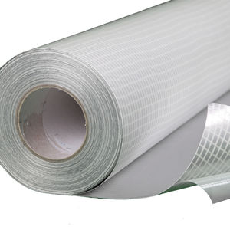
Film membrane
This could be a very valid option thanks to its characteristics that embodies the ones of the previous materials. This film gives the proper isolation and allows air circulation, it is the most used choice in wood construction.
This material offers good behaviour towards Source: web 5
condensation and protects against water penetration, can resist huge change temperatures, gives a proper interchange of gases between interior and exterior, the multilayer structure of material usually is reinforced with aluminium paper and this helps the isolation and temperature maintenance during winter.
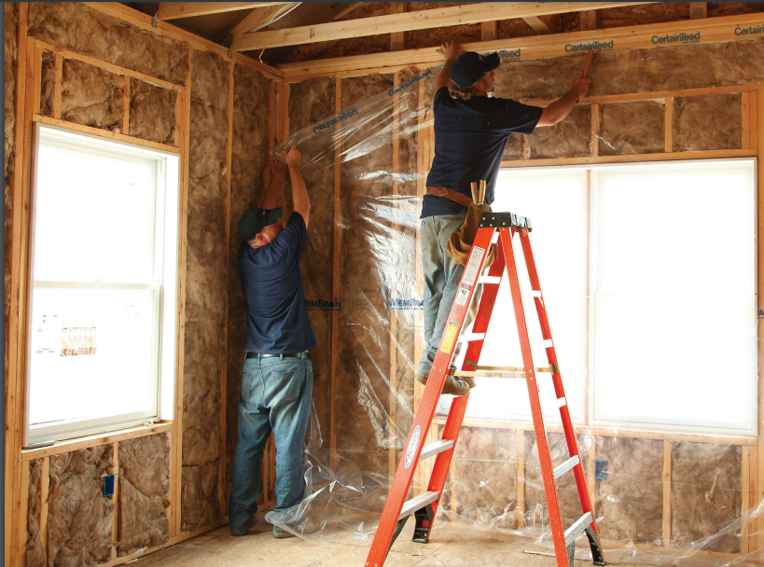
The vapor barrier will be disposed according to the type of work carried out, in a house the wall is isolated from the interior, in a basement the vapor barrier will be in the exterior and in some peculiar situation the isolation will be carried out in both sides interior and exterior. Before executing every kind of work, it is necessary some type of preparation of the workspace and Source: web 4
surface; cleaning must be done, and a protector sheet is needed. Liquid rubber is used, applied with a special gun by pression. When the barrier is done externally, the action of cold winds and humidity must be taken in account, providing a sheet that supports that.
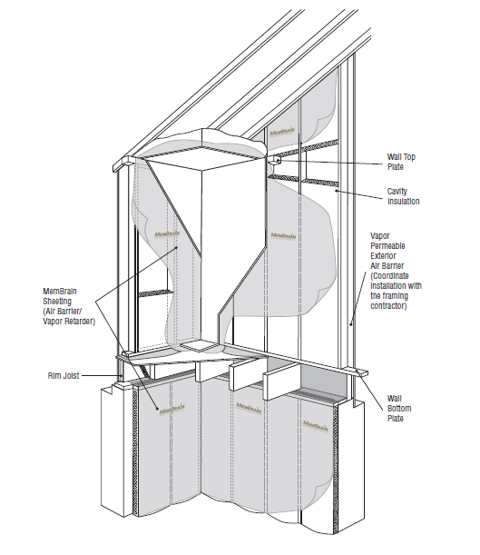

Source: web 3

A time of minimum 4 years must pass until the colocation of the barrier is possible, is better if the installation is carried out on naked wood previous the isolation. In the case of an internal barrier, this is executed immediately after construction works. The movement of the condensed water must be considered leaving a small space during the installation.
Wet technology
Clay plaster
In terms of “breathability” clay plasters not only have excellent vapour permeability but also extremely good hygroscopic qualities which mean that mold caused by condensation are minimized. Clay plasters have a much more rapid uptake of moisture from the atmosphere than with other materials such as timber, which take in and release large quantities of moisture but over a much longer period. They can therefore act to protect vulnerable organic materials (and in particular timber) from high levels of relative humidity, when microbial and insect attack can be triggered. Particularly with modern building usage (showers, cooking and indoor living) this can be an important strategy in the control of excess moisture in vulnerable buildings.
Clay plasters are flexible in relation to their fiber content and are able to hold together the plaster without cracking in situations of minor or gradual movement. This is a significant quality improvement in old buildings. Clay plasters are reversible and re-workable provided. Also, they are not pollutant and, even unpainted, have a very particular aesthetic. Clay also works extremely well with internal wall insulation solutions with wood fiber boards, like Steico, IsoPlaat, Soprema, RB&B boards (fig.)

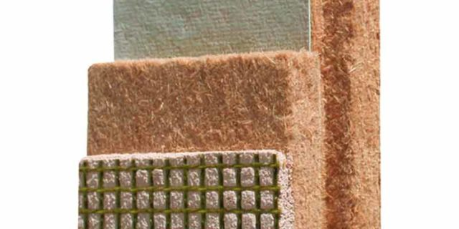

Benefits of clay:
- Antistatic
- Moisture regulation in room;
- Eco friendly;
- No residuals, no waste;
- If the clay plaster application work is stopped, it can be continued in future – no sticking joints are visible;
- Easy to repair holes or damages in plaster in living process.

https://tallerconco.org/wp-content/uploads/2017/05/Straube_Moisture_Tests.pdf
https://www.soprema.co.uk/en
ekovate.lv

Lime plaster
Lime plaster is made up of sand, water and lime. There can often be confusion due to the fact that the term lime is used to refer to a huge assortment of different products some of which go by different names that mean the same thing.
When it comes to Lime Plaster, we’re usually referring to non hydraulic lime which may be referred to as hot lime, lime putty or fat lime. Lime plaster can also sometimes be confused with cementitious plasters containing lime. Below we’re going to try and explain the different terms used within the construction and restoration industry as well as the benefits of using each product.
The lime in question is usually Non-Hydraulic Lime, which of course is also known as Lime Putty. Incredibly, the use of Lime Plaster dates back as far as 7200BC where statues sculpted in Lime Plaster were found buried in a pit at the archaeological site of ‘Ain Ghazal in modern-day Jordan. This is a perfect example of just how durable Lime Plaster is as a building material.
Often products can be used as both a Lime Plaster and a Lime Render as the Lime Putty used is durable enough to withstand the weather conditions encountered in external use. This is just one of the many benefits of using lime plaster or lime render. Though this is dependent on climate and geographical location.
Benefits of Lime Plaster
- Lime plaster is permeable and allows for the diffusion and evaporation of moisture.
- Lime Plaster has a high pH which acts as a fungicide; meaning mold will not grow in lime plaster.
- Plaster made from lime is less brittle and less prone to cracking than cement plaster and requires no expansion joints.
- Lime plaster is less affected by water and will not soften or dissolve like drywall and earthen or gypsum plaster
- Unlike gypsum or clay plaster, lime plaster is durable enough to be used as a lime render on the exterior of buildings.
- Saving time by allowing you to go to depths of 40mm per application.
- Insulating properties with a k value of 0.19.
- Draws moisture out of the building keeping it dry.
- Cost saving by enabling you to dub out and level all in the same coat.
- Aiding with salt migration.
- Increasing soundproofing and acoustic performance.
- Easier to apply.
- Cutting down labour cost with less coats required.
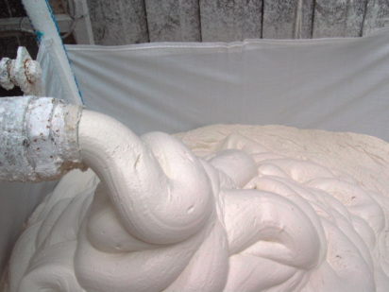
ECOLIME, Lime plasters: What is Lime Plaster?, 2018, https://unitylime.co.uk/about-us-blog-what-is-lime-plaster/

LIST OF REFERENCES
Bibliography:
-web1:
https://www.archiexpo.es/cat/aislamientos-e-impermeabilizantes/barreras-vapor-AL-3218.html
-web 2
https://www.ursa.es/faq/10-dudas-sobre-barrera-de-vapor-y-condensaciones/
-web 3
https://www.certainteed.com/resources/30-28-137_MembrainInstallationGuide_July_2019.pdf
-web 4
https://www.certainteed.com/resources/30-28-159_MemBrainTechnicalBrochure_July_2019.pdf
-web 5
https://www.google.com/imgres?imgurl=https%3A%2F%2Fimg.archiexpo.es%2Fimages_ae%2Fphoto-m2%2F94704-12435936.jpg&imgrefurl=https%3A%2F%2Fwww.archiexpo.es%2Ffabricante-arquitectura-design%2Fbarrera-vapor-aluminio-13458.html&tbnid=35XE-taVLQjh8M&vet=12ahUKEwjcg6rB-MHtAhXFw4UKHVYsBoEQMygIegUIARCuAQ..i&docid=wRuEUsdIKu2p7M&w=300&h=300&q=membrana%20aluminio%20barrera%20corta%20vapor&ved=2ahUKEwjcg6rB-MHtAhXFw4UKHVYsBoEQMygIegUIARCuAQ

